СУБД

Экзамен

# Иван Заваруев, ПИ19-1в

# Вариант 14

## Тест

## Задача



select count (Class.name) from Class where Class.name like ‘10%’

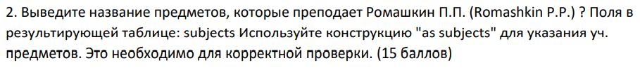

select sub.name as subjects from Subjects sub

join Schedule sc on sc.subject = sub.id

join Teacher t on sc.teacher = t.id

where t.last_name = ‘Romashkin’ and t.first_name like ‘P%’ and t.middle_name like ’P%’

select count (distinct Schedule.classroom) as count from Schedule where Schedule.date = ‘2019-09-02’